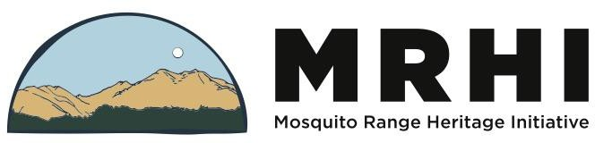

Description:

Conservation Field Technician 2024
Mosquito Range Heritage Initiative is an Alma, Colorado based non-profit organization committed to conserving and enhancing our cultural, recreational and natural resources in the high country of the Mosquito Range. We identify, monitor and map the locations of rare plants in the Mosquito Range utilizing GPS technology. In addition to identifying the location of the plants, nearby hiking and mountain biking trails and 4X4/ATV roads, mining claims, historic sites, and private property may also be identified. We utilize results to develop and implement conservation plans to protect rare plant communities through conservation trail work by volunteers in coordination with USFS trail crews. We will also educate community residents and visitors on our rare alpine and native plants and methods to preserve and protect them.

This is a full-time position from June through early September. Exact dates are plant and weather dependent. It is physically demanding, requiring long days in the field working at altitudes from 9,000’ to 14,000’. The candidate should be in excellent physical shape and confident working in a high alpine environment. This position requires a strong conservation ethic, team skills, and a desire to work in a challenging but beautiful backcountry area.

The Conservation Field Technician is hired by the Mosquito Range Heritage Initiative with work tasks assigned by MRHI’s Executive Director and the Project Coordinator. Project employees will be trained in rare plant identification by South Park Ranger District’s Natural Resource Specialist.

Responsibilities:
- Participate in the creation of a detailed botanical survey of rare alpine plant communities.
- Educate community residents & visitors on our rare alpine plants and methods to preserve and protect them.
- In field GPS data collection of plants and nearby trails and mining claims using GPS/mobile mapping devices such as a Cedar CT8 tablet using ESRI Collector
- Download field data to GIS maps and other computer programs for analysis.
- Digital photography to document findings and link photos to GPS points.
- Educate self and utilize knowledge of alpine ecology and Leave No Trace principles.
- Daily and weekly compilation of field reports.
- Participate in conservation field work including habitat restoration and illegal road closures.
- Use Google Docs for all project documentation.
- Record time accurately on the MRHI timesheet.
- Ensure that equipment handoff occurs when necessary.
- Other tasks as assigned.

Required Skills:
  - Strong organizational and planning skills
  - Excellent outdoor skills
  - Strong knowledge or interest in botany and excellent attention to detail
  - Computer skills and knowledge of word processing, spreadsheet, and database software

- Comfortable with the use of a GPS unit
- Experience/ability in habitat restoration, trail building and maintenance
- Knowledge of rare plants in the Mosquito Range (can be gained through Rare Plant Monitor training)

Desired Qualifications Technical/Physical
- Demonstrated experience with ArcGIS base package and ArcPad mobile mapping or the ability and willingness to learn the software.
- Excellent physical condition, willingness and ability to hike at high altitude (12,000+ feet) and hike for multiple consecutive days.
- Proficiency in traveling (hiking and navigating) and safety in mountain backcountry environments both on and off trail.
- Hiking could involve up to 15 miles per day at altitude, carrying a heavy pack and working and contributing as part of a team.
- Some botany/ecology background (through education and/or work experience)

Other desirable qualifications
- Trails Crew Leader training experience
- An interest in rare plants and trails of the Mosquito Range
- Passion about the outdoors and a strong conservation ethic
- CPR Certification
- Wilderness First Responder or Wilderness First Aid Certification (preferred) or current First
Aid Certification
- Team spirit, sense of humor

All Applicants must have
- A reliable vehicle with FOUR-WHEEL DRIVE to get to the work sites (mileage reimbursed from office)
- Outdoor equipment (pack, rain gear, etc.)
- Physical examination and clearance by a doctor
- Current health insurance
- Driver’s license and a clean driving record

Work Schedule and Salary
This seasonal position is expected to run from June to September 2023. The weekly work schedule will be variable (averaging 40 hours/week) with occasional evenings and weekends required. Travel with a personal vehicle is required. The work is physically demanding and is performed at high altitude in a backcountry environment. Position is expected to be 80% field and 20% office based during the field season. MRHI will reimburse mileage for use of your personal vehicle. Anticipated wage: $20-24/hour depending on experience.

How to Apply
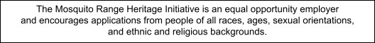
Submit a cover letter and resume. Finalists may be required to complete a medical history and provide a physician’s release form. If you have questions, contact Cara Doyle at (719) 839-0351. Application deadline March 1, 2024 or until filled. Email application to info@mrhi.org.

